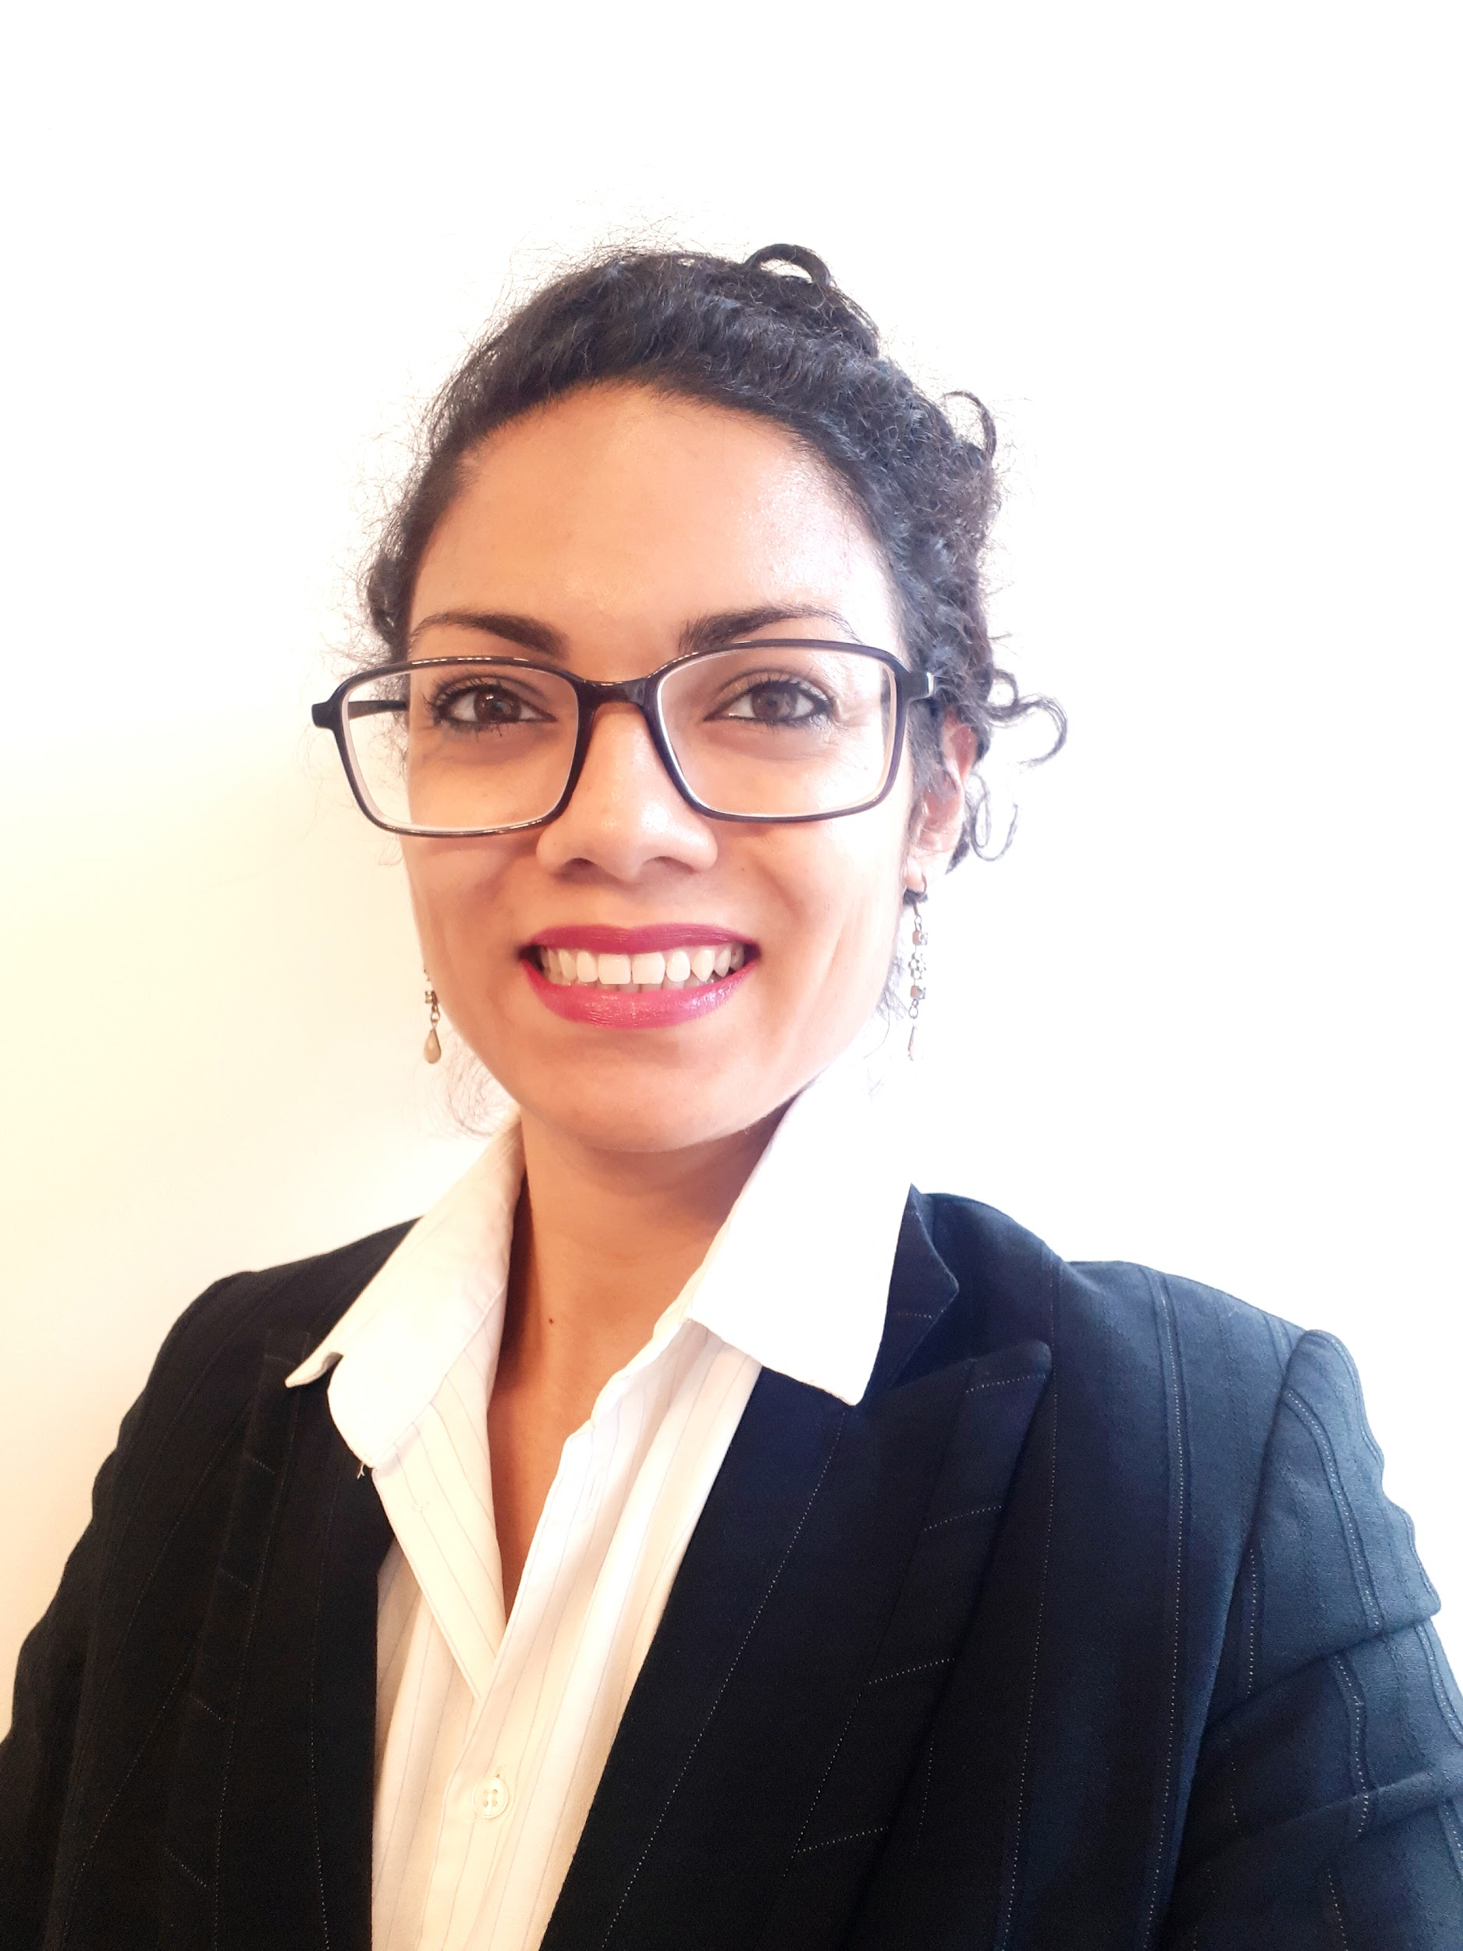
Omaira Gill
Investment Writer
  Athens, Greece
  (+30) 694 875 7885
  omaira.gill@gmail.com
  https://www.linkedin.com/in/omairagill/

 | Skills
Proofreading
Communications
MS Office
Excel
Interviewing
Research
Data mining
Team management
Copywriting and editing
AI prompt engineering
Fixed income and equities

 | Work History
2021-Current  2019-03 – Current | Investment writer  Copylab Group  In this role, I am responsible for a variety of investment writing projects, including editing, proofing and writing monthly and quarterly reports from attribution, fixed income market reports and shareholder reports, award submissions, executive summaries from meeting recordings, the creation of RFPs, RFIs and DDQs for a variety of corporate clients, project management across various geographic locations and liaising with teams and SMEs across several geographic locations.  Press Officer  World Duchenne Organization, Athens, Greece (voluntary)  As the press officer for the World Duchenne Organization, I am responsible for editing, proofreading and producing content relevant to the activities of the organization, which promotes awareness and treatment exploration for Duchenne Muscular Dystrophy.  This often involves dealing with medical language and medical research terminology.

2017-05 – 2021-01 | Business Reporter  Macropolis.gr, Athens, Greece  • Convert press releases from various Greek government bodies, the EC and the IMF into stories  • Analyse economic trends and interpret the numbers for business coverage  • Write summaries of market activity including bond sales and macroeconomic indicators for Greece and regionally  • Write quarterly, half-year and full year business reports for 20 Athens Stock Exchange-listed companies  • Write in-depth economic features using Eurostat data sets  • Edit and proofread content  • Work closely with the editor to ensure adequate volume and coverage throughout the day  • Compose weekly newsletter  This is a highly deadline-drive role where attention to detail is crucial.

2004-01 – Current | Freelance Journalist  Various, Global  As a freelance journalist, I have covered several major new events from Greece including the refugee crisis, economic crisis and insights into various business sectors.  I have also covered contemporary topics such as tourism in Greece, accessibility and health and wellbeing. Apart from print journalism, I have also contributed my insights for broadcast media.  Publications my work and commentary has appeared in include the Washington Post, the Guardian, USA Today, DW news, the National (UAE) and the BBC.

2016-01 - 2017-01 | Staff Writer  Kathimerini, Athens, Greece  As staff writer on the team of Greece Is, Kathimerini's English-language travel magazine, my duties included:  • Maintaining the magazine's social media feeds  • Writing original travel and lifestyle content  • Translating articles from Greek to English  • Interviewing  • Editing translations from other sources  • Editing and proofreading copy for the print and online magazine  advertising copywriting  • Content creation for the marketing department
2014-07 - 2015-01 | Content Marketing Executive  Incrediblue, Athens, Greece  As Content Marketing Executive for Incrediblue, a yacht rental startup, my role covered the following:  • Writing content and specs for newsletters, landing pages, press releases, site pages and more  • Managing a team of content writers, produce and distribute content across media  • Developing written materials, story pitches, press releases  • Handling media inquiries, blogger relationships and more  • Managing email marketing campaigns including planning, copy writing, list selection, scheduling, and reporting  • Optimising content and copy used in campaigns based on metrics  • Designing a communications strategy to increase conversions  • Designing seasonal, event-based and offer-based promotions

2013-03 - 2014-09 | Freelance Senior Copywriter  Copelouzos Group, Athens, Greece  As freelance Senior Copywriter for the web and smartphone application branch of Prime Media SA by Copelouzos Group, one of Greece's largest companies, my duties included:  • Proofreading all materials  • Checking Greek to English translations for accuracy  • Creating original copy  • Sales copy for the mobile app stores  • Press releases  • External marketing material content  • Social media content  • App testing  • Liaising with the rest of the development team for delegation and problem solving

2005-09 - 2013-09 | Marketing Associate  Rogge Global Partner Plc, Athens, Greece  Providing Marketing assistance to Portfolio Managers, Marketing Managers and other members of staff. My duties included:  • Creating presentation material focused on fixed income, credit, aggregate, high yield and emerging market products  • Writing and editing new marketing material and compiling DDQ, RFI and RFP answers  • Fund reporting writing, editing and proof reading  • Proofreading completed RFPs  • Attending business acquisition pitches and meetings for existing clients  • Assessing tender calls for suitability and responding as necessary  • Identifying the RFP response team and delegating tasks  • Coordinating RFP answers from multiple teams in multiple locations  • Creating and maintaining RFP answer database  • Updating contacts databases  • Training new staff

 | Education
2004-02 - 2006-06 | Master of Arts: Journalism  University Of Westminster - London, UK

2000-09 - 2003-06 | Bachelor of Arts: Journalism  Cardiff University - Cardiff, UK

 | Languages
English (Native)
Greek (Fluent)
Urdu (Native)
Hindi (Native)
Arabic (B2 certificate verified by An-Najah University, Palestine)

 | Training
2022-10  2021-06  2017-10  2012-06 | European Patients’ Academy on Therapeutic Innovation (EUPATI) Patient advocacy graduate  Promoting Gender Equality in the Workplace – British Embassy, Athens  Reporting Sustainable Development and Migration – Thomson Reuters Foundation  Investment Management Certificate – CFA UK

